
AMERICAN INTERNATIONAL UNIVERSITY-BANGLADESH
FACULTY OF SCIENCE & TECHNOLOGY
DEPARTMENT OF COMPUTER SCIENCE & ENGINEERING
COURSE: INTRODUCTION TO DATA SCIENCE
FALL 2024-2025
Section: C
Group – 05

Supervised By
Tohedul Islam

MID TERM PROJECT - 1

SUBMITTED BY:
NAME | ID
ABDULLAH KHONDOKER | 22-46373-1
SARAH BINTE ISLAM | 22-46685-1
F. M SHARIAR | 22-46532-1
FAIZA BINTE ZAMAN | 22-47256-1

Date of submission: 14th December, 2024
Dataset Details:
One of the most popular datasets used to conduct binary classification projects for teaching machine learning and data science is the Loan Approval Dataset. It contains 201 rows and 14 columns, with features of each applicant, such as age, gender, education level, income, years of employment experience, home ownership status, loan amount, loan intent, loan interest rate, percentage of income allocated to the loan, credit history length, credit score, whether there were previous loan defaults on file, and the loan approval status.
Installing packages:
R code:
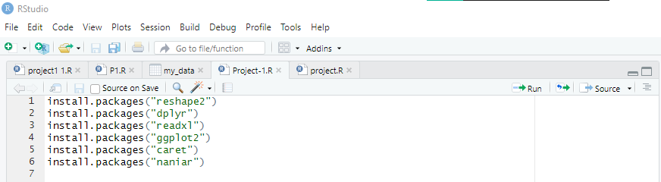
Description:
Installs several essential packages for data manipulation, analysis, and visualization in R. These include reshape2 for restructuring data, dplyr for data transformation, readxl for importing Excel files, ggplot2 for advanced plotting, caret for machine learning model training, and naniar for handling missing data.
Loading Libraries:
R code:
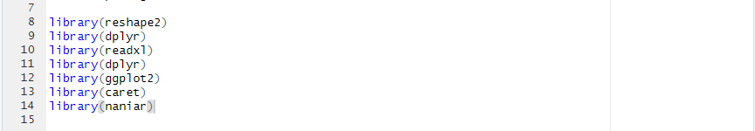

Description:
Loads a set of libraries crucial for data processing, analysis, and visualization.

Importing .xlsx file:
R code:
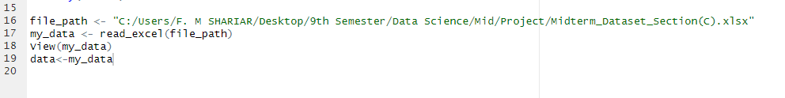
Output: 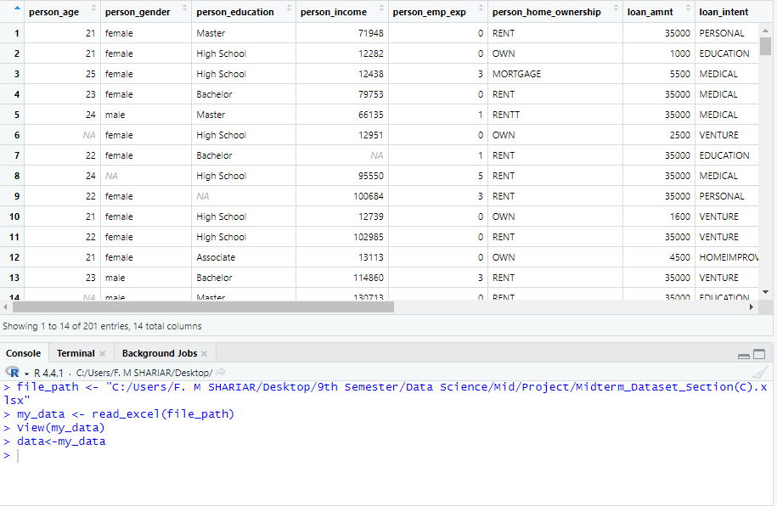
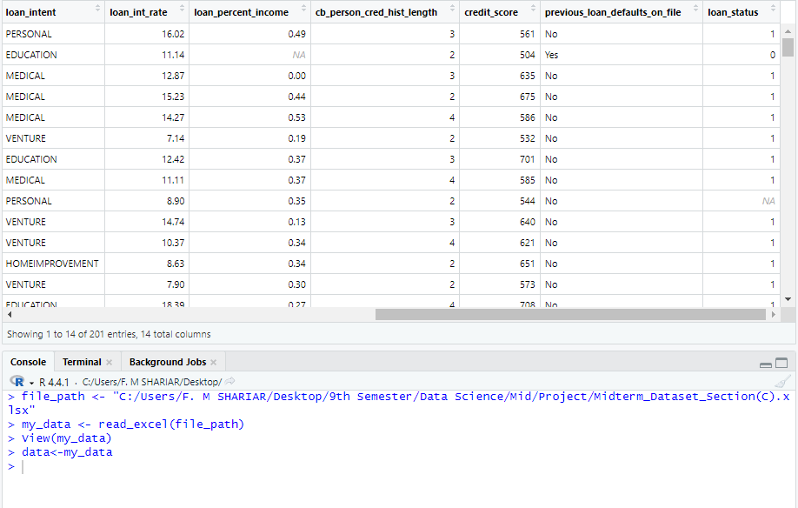
Description:
It specifies the file path to the Excel file stored. The read_excel function from the readxl library is used to load the data into R and save it in a variable called my_data. The View function is then used to open the data in RStudio, allowing to visually inspect it. Finally, the data is copied from my_data to another variable called data for further manipulation or analysis. This process is a standard starting point for loading and reviewing data in R.
Initial Data Preview:
R code:
Output:
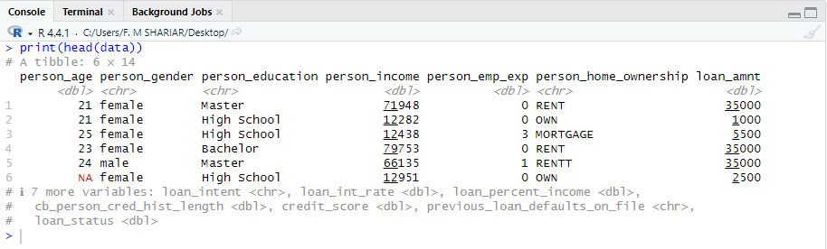
Description:
Displays the first few rows of the dataset stored in the variable data. This helps in quickly inspecting the data's structure and initial values, commonly used to verify the data loading process and gain an initial understanding of the dataset.
Visualize Missing Value:
R code:

Output:
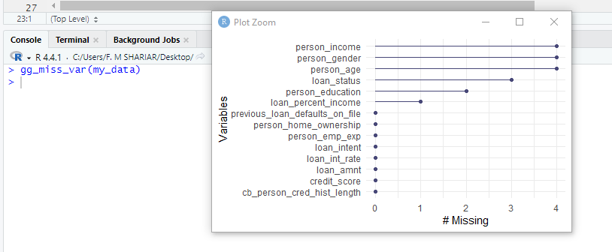
Description:
Creates a plot to visualize missing data across different variables in the dataset my_data. It displays the proportion of missing values per variable, helping identify areas that may require data cleaning or imputation.
Handling Missing Value (Omit Row):
R code:
Output:
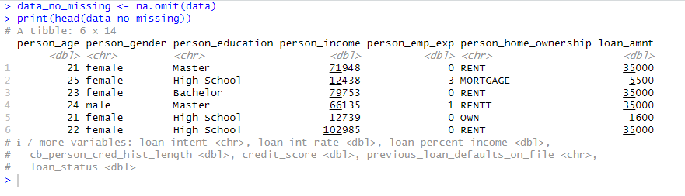
Description:
Creates a new dataset data_no_missing by removing all rows with missing values from data using na.omit(data). Then, it displays the first few rows of this cleaned dataset with print(head(data_no_missing)) to verify the removal of missing entries.
Handling Missing Value (Replace Numeric/Median-Categoric/Mode):
R code:
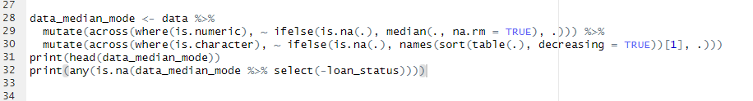
Output:
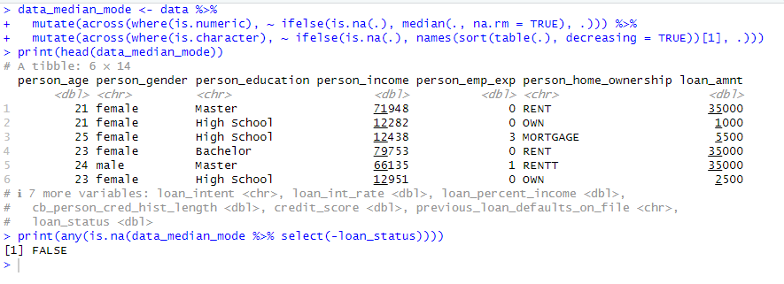
Description:
Handles missing values in data by replacing them in numeric columns with the median and in categorical columns with the mode. It utilizes dplyr's mutate and across functions for these imputations. After adjustments, the script displays the initial rows of data_median_mode to confirm the changes. Lastly, it checks for any remaining missing values in the dataset, excluding the loan_status column.
Handling Missing Value (Replace Numeric/Mean-Categoric/Mode):
R code:
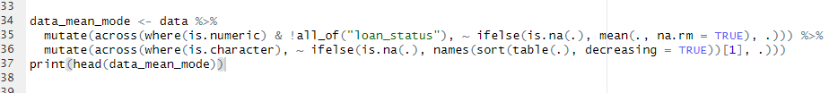
Output:
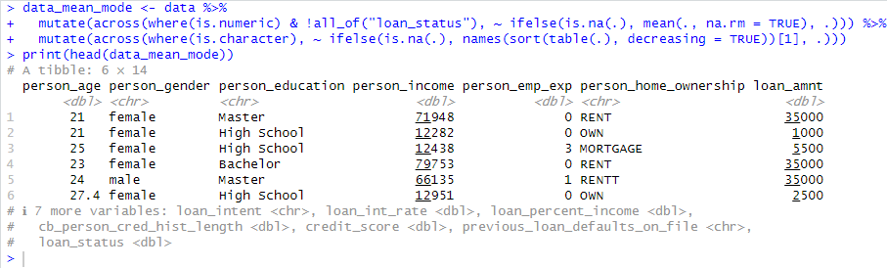
Description:
Handles missing values in the dataset data by using different strategies for numeric and categorical data. Numeric columns, except loan_status, have missing values replaced with the mean, while categorical columns use the mode.After making these changes, it displays the first few rows of data_mean_mode to confirm the successful handling of missing values.
Handling Missing Value (Replace Numeric/Min-Categoric/Unknown):
R code:
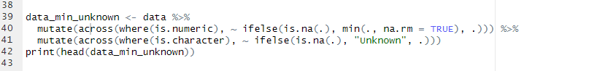
Output:
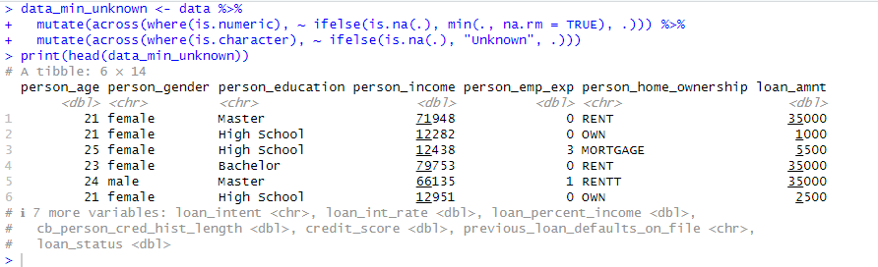
Description:
Modifies the dataset data by replacing missing values: numeric columns with the column's minimum value and categorical columns with the string "Unknown". Afterward, the script displays the first few rows of data_min_unknown to confirm the changes, ensuring all missing values are appropriately handled.
Dataset Without Missing Value:
R code:
Description:
Updates the data variable to contain the dataset data_median_mode, which has undergone median and mode imputation for missing values. This allows further operations to use the modified dataset.
Unique Values in Person Home Ownership:
R code:
Output:
Description:
Displays the unique values from the person_home_ownership column in the data dataset, providing a quick overview of the different home ownership types recorded.
Handling Invalid Value by Data Correction:
R code:
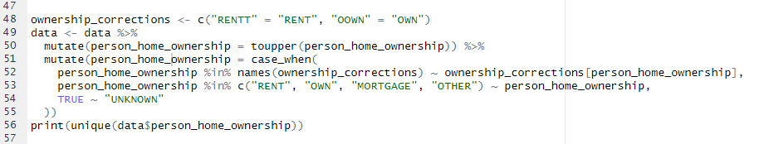
Output:
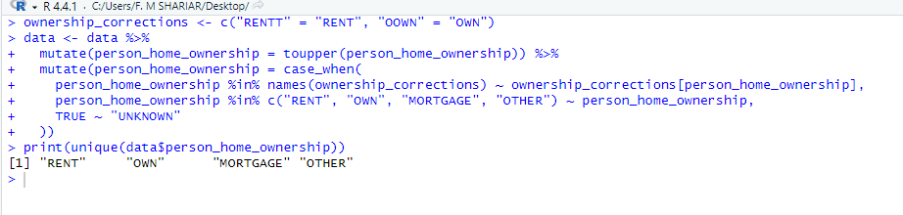
Description:
Standardizes the person_home_ownership column in the data dataset by converting all entries to uppercase and correcting specific mislabelled entries using predefined mappings. It checks for valid categories ("RENT", "OWN", "MORTGAGE", "OTHER") and assigns "UNKNOWN" to any outliers and then prints the unique values in the updated column to confirm the applied corrections and standardization.
Convert Loan Status to a Factor:
R code:
Description:
Converts the loan_status column in the data dataset to a factor, which is useful for statistical modeling and analysis that requires categorical inputs.
Identify Minority and Majority Classes:
R code:
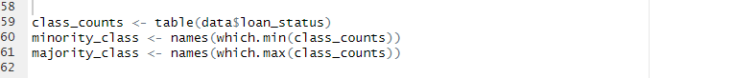
Description:
Calculates the frequency of each category within the loan_status column of the data dataset and identifies the minority and majority classes. It uses the table() function to count occurrences of each class in loan_status, then determines the class with the fewest instances (minority_class) and the one with the most instances (majority_class) by applying the which.min() and which.max() functions respectively to the counts.
Handling Imbalance Data (Oversampling):
R code:
Description:
Addresses class imbalance by oversampling the minority class in the data dataset. First, it filters rows where loan_status matches the minority class, then oversamples these rows to equal the frequency of the majority class using slice_sample() with replacement. Finally, it combines these oversampled rows with those from the majority class to create balanced_data, a new dataset with an equal number of instances for each class.

Handling Imbalance Data (Undersampling):
R code:
Description:
Addresses class imbalance by undersampling the majority class in the data dataset. It first isolates rows where loan_status matches the majority class, then randomly selects a subset equal to the number of minority class instances using slice_sample(). These rows are combined with those of the minority class to form balanced_data_undersample, a new dataset that ensures equal representation of both classes.
Print Oversampling Data:
R code:
Description:
Displays the frequency of each category in the loan_status column of the balanced_data dataset, allowing verification of successful class balancing for further analysis.
Print Undersampling Data:
R code:
Output:
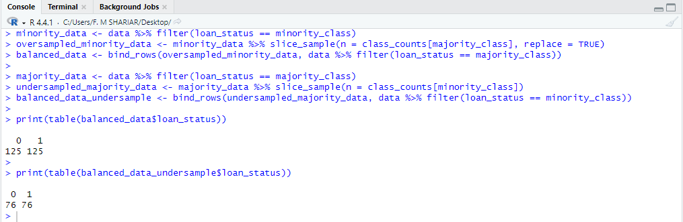
Description:
Displays the class frequencies in balanced_data_undersample to confirm successful class balancing through undersampling.
Bar Plot Data Distribution:
R code:
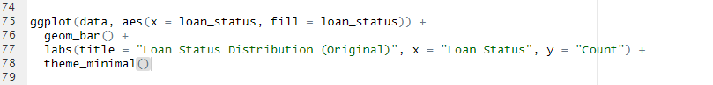
Output:
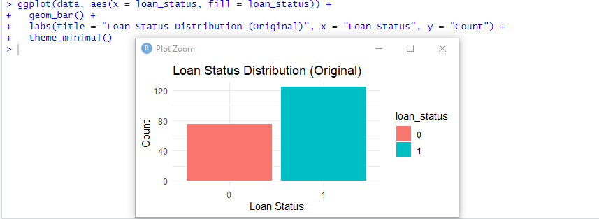
Description:
Create a bar plot showing the distribution of loan_status in the original data dataset. It maps loan_status to the x-axis and fill color, adds a title and axis labels, and applies a minimal theme for clarity. The plot highlights the frequency of each class, making it easy to identify class imbalances.
Bar plot Data Distribution After Oversampling:
R code:
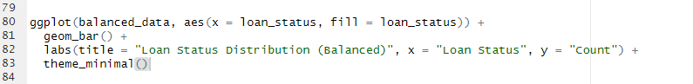

Output:
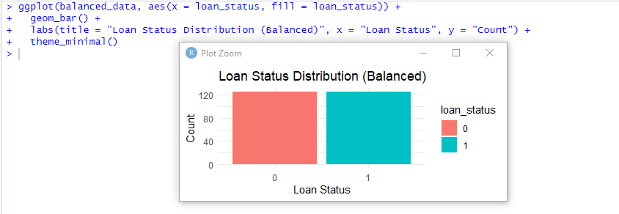
Description:
Create a bar plot displaying the distribution of loan_status in the balanced_data dataset. It maps loan_status to the x-axis and fill color, adds a title ("Loan Status Distribution (Balanced)") and axis labels, and applies a minimal theme. The plot visually confirms that the dataset has been balanced, with equal counts for each class.
Bar plot Data Distribution After Undersampling:
R code:
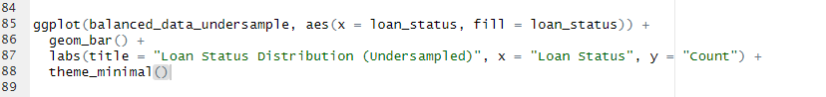
Output:
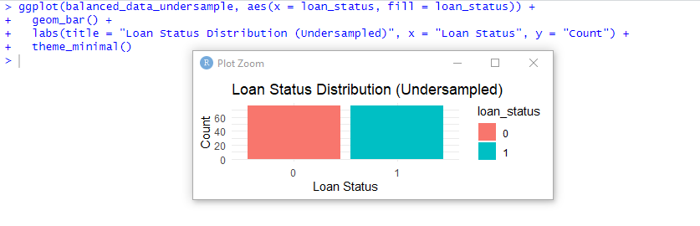Description:
Create a bar plot illustrating the distribution of loan_status in the balanced_data_undersample dataset. It maps loan_status to the x-axis and fill color, adds a title ("Loan Status Distribution (Undersampled)") and axis labels, and applies a minimal theme. The plot confirms that the dataset has been balanced through undersampling, showing equal counts for each class.
Check and Remove Duplicates:
R code:
Description:
Removes duplicate rows from the data dataset, ensuring all entries are unique and cleaning the data for analysis.
Detect and Handle Outliers:
R code:
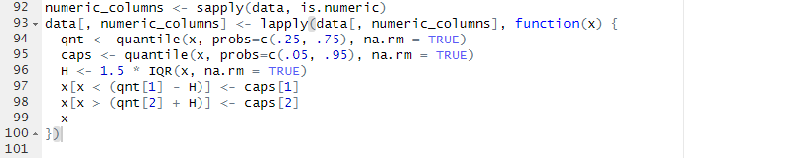
Description:
It calculates the interquartile range (IQR) to identify outliers, which are values far below the 25th percentile or far above the 75th percentile. Any outliers are replaced with the 5th percentile (for very low values) or the 95th percentile (for very high values), ensuring the data remains consistent without extreme values. The updated columns are then saved back into the dataset, reducing the impact of outliers while preserving the overall structure.
Normalize Person Income:
R code:
Output:
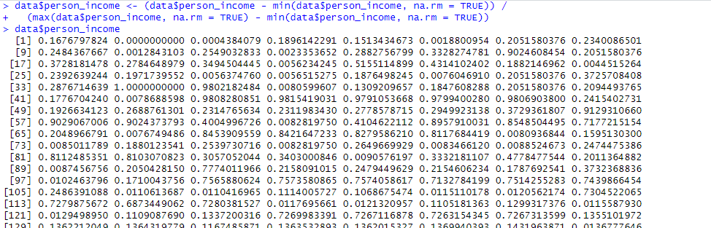
Description:
Normalizes the person_income column in data to a 0–1 scale by subtracting the minimum value and dividing by the range (max - min), ensuring all values are comparable and on the same scale.
Transform Attribute:
R code:
Output:
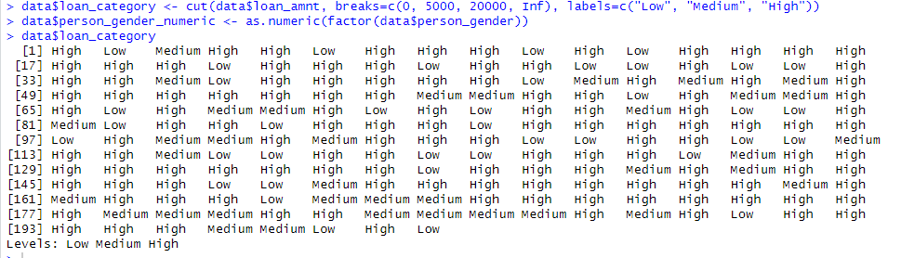
Description:
Adds two new columns to data: loan_category classifies loan_amnt into "Low," "Medium," and "High" based on ranges, and person_gender_numeric converts person_gender into numeric codes for analysis.
Histogram of Person Income by Loan Status:
R code:
Output:
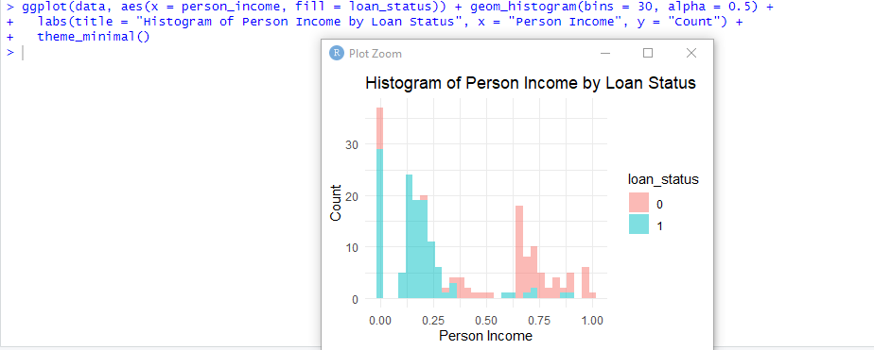
Description:
Create a histogram showing the distribution of person_income by loan_status nd helps to visualize income patterns related to loan status.
Correlation Heatmap:
R code:
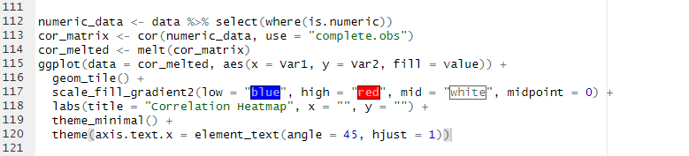
Output:
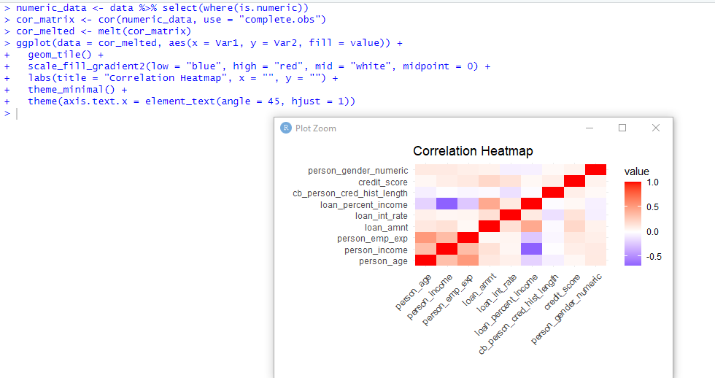
Description:
Creates a correlation heatmap to visualize relationships between numeric variables in the data dataset. It calculates pairwise correlations, melts the matrix into a plottable format, and uses ggplot2 to map correlations to colors—blue for negative, red for positive, and white for neutral.
Proportion of Loan Status by Home Ownership:
R code:
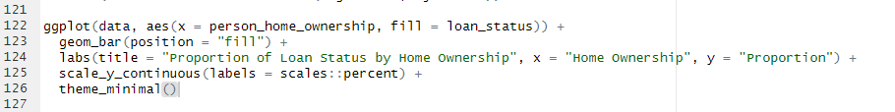
Output:
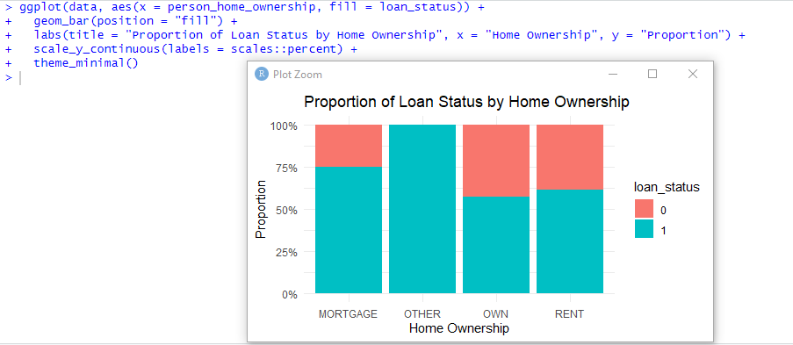
Description:
Creates a proportional bar plot to show how loan_status varies across different person_home_ownership categories.
Save the Dataset in a .csv File:
R code:
Description:
Saves the data dataset to a CSV file in the specified directory. The argument row.names = FALSE ensures that row numbers are not included in the file, keeping the output clean and focused on the dataset's content.
Final Structure of the Dataset:
R code:

Output:
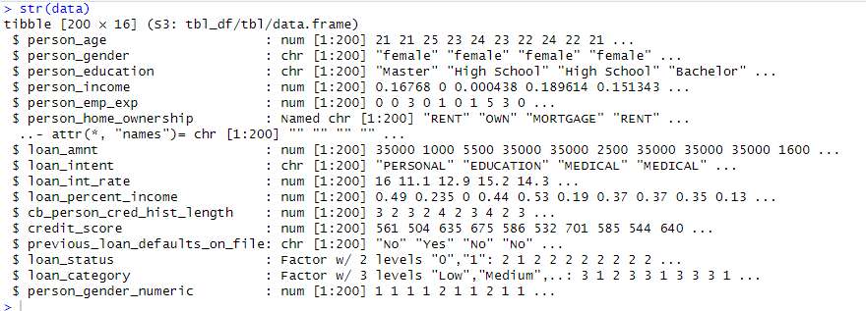
Description:
Provides a quick summary of the data dataset, showing its structure, the number of rows and columns, column names, data types, and a preview of the first few values in each column. It helps verify the dataset's format for analysis.
Final Summary of the Dataset:
R code:
Output:
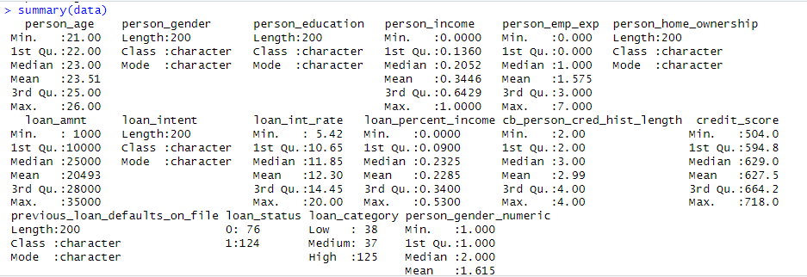
Description:
Provides a statistical summary of each column in the data dataset. For numeric columns, it shows metrics like minimum, maximum, mean, median, and quartiles. For categorical columns, it displays the frequency of each category.

